Healthy Eating Policy
Introductory Statement
This Healthy Eating Policy was drafted by the staff of C.B.S. Primary School as a review of our initial policy introduced in 2012. The introduction of our Healthy Eating Lunch Policy created an awareness of the importance of good nutrition for pupils throughout their school day and has positively influenced the quality of daily lunches brought by our pupils. However, it is now time to refine some elements of our original policy and to bring it up to date in line with new findings and research and also the introduction of a revised food pyramid.

Rationale
As part of the Social, Personal and Health Education (S.P.H.E.) Programme we encourage the children to become more aware of the need for healthy food in their lives. In view of the recent media emphasis on obesity and life style trends we feel it of vital importance to educate the children in our school to develop healthy eating habits for life. By having this policy we aim to encourage and develop these healthy habits and encourage our pupils to make healthy choices in their everyday lives. Research has shown that inadequate nutrition impacts negatively on children’s ability to learn and benefit from education. Proper nutrition can improve children’s ability to concentrate, improve disruptive behaviour and encourage children to attend school.
Aims
- To promote the personal development and well-being of the child.
- To promote the health of the child and provide a foundation for healthy living in all aspects.

Objectives:
- To enable the child to appreciate the importance of good nutrition for growing, developing and staying healthy.
- To enable the child to accept some personal responsibility for making wise food choices and adopting a healthy, balanced diet.
- To encourage children to eat a proper balanced diet and to promote healthy eating at home as well as in school, which includes the importance of a healthy balanced breakfast to ensure good concentration at school.
- To promote good hydration throughout the day at home and at school by drinking water and healthy alternatives.

Guidelines for a Healthy School Lunch
This policy provides guidelines and recommendations in accordance with the most recent food pyramid so that informed choices are made when deciding which foods to include when making balanced, nutritional lunches for children.
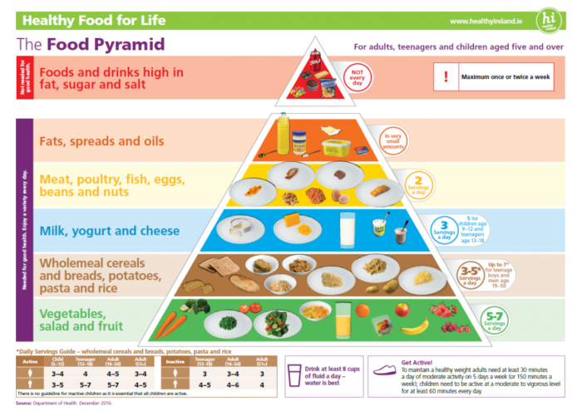
Some healthy drink and snack suggestions we encourage are provided on the link below:
https://www.safefood.eu/Education/Primary-(ROI)/Healthy-lunchboxes.aspx

Suggestions for your child’s school lunch:
- Fruit – apple, oranges, banana, grapes, pear, plum, peach, apricots, melon, grapefruit, pineapple, strawberries, raspberries, mango, blackberries or blueberries. Remember to peel and/or cut fruit and vegetables into bite-sized pieces for younger children.
- Raw vegetables – tomatoes, sweet corn, peppers, carrot sticks, celery sticks, broccoli, cabbage or cucumber
- Breads – whole-grain breads, rolls, bagels, wraps, soda bread or pitta
- Bread substitutes – oatcakes, plain rice cakes, pancakes or crackers
- Fillings – cheese, tuna, hummus, cold meats, pate, egg, lettuce, spinach, cucumber, tomato, onion, peppers, coleslaw, salad, or banana
- Dairy: yogurt (not ‘Frubes’), cheese
- Drinks: Water (each classroom is equipped with a filtered drinking water tap, children should have a reusable water bottle, preferably with a non-spill top), Milk

Foods not allowed in school:
- Crisps and popcorn
- Fizzy drinks, sports drinks and drinks/juices with high sugar content
- Sweets
- Nuts/Peanuts, Nutella, chocolate spread or any foods containing nuts or traces of nuts are not allowed under any circumstances. There are a number of pupils in our school who have severe nut allergies.
- Chocolate biscuits/bars, chocolate covered rice cakes, etc
- Cereal Bars (due to high sugar content and traces of nuts)
- Fruit Winders (due to high sugar content, 37%)
- Squeezable Yogurt tubes like ‘Frubes’ (due to spillages when opening)

Special Dietary/ Medical Requirements
Parents of children with special dietary requirements are required to make an appointment with the principal to discuss the implications of this policy.
Children are not allowed to swap or share lunches due to allergies/special dietary requirements.

Packing the Lunch Box
Children should be able to unwrap and eat their lunches by themselves. It is not possible for teachers to open lunches in a classroom full of children. Please help by not giving products that they cannot open themselves e.g. foods with wrappers, unpeeled oranges etc. To save time, please ensure all food is well prepared (e.g. fruit peeled and chopped if necessary and sandwiches cut).
As we are a ‘Green School’, trying to reduce the amount of waste in the school, parents are encouraged to reduce/eliminate the amount of packaging in their child’s lunch box and use reusable/sustainable packaging where possible. Children are asked to take packaging, empty cartons, uneaten food, etc. home again in their lunchbox.

Initiatives that support this policy:
- In conjunction with the SPHE (Social, Personal and Health Education) curriculum, children in C.B.S. Ennis will receive a number of lessons on Healthy Eating at the start of each school year. This will serve as a reminder of school policy, the food pyramid, food labelling, sugar, salt and fat facts, portion size, making lunch ideas etc. so that they are informed of the components of a healthy, balanced diet.
- Food Dudes Programme: Food Dudes is an award winning curriculum-linked evidence-based healthy eating programme, developed to encourage children to eat more fresh fruit and vegetables. It is based on repeated tastings of fresh fruit and vegetables, rewards and positive role models. This programme was rolled out for all classes in the C.B.S. Ennis during the 2018/2019 school year.

Roles and responsibilities:
Each class teacher will co-ordinate the progress of this policy and can encourage the children to bring healthy lunches but ultimately the responsibility for ensuring that children eat healthily lies with the Parent /Guardian of each child.

Review:
This policy will be reviewed every two years and amended as deemed necessary.
Ratification:
This plan was ratified by the Board of Management on ____________.

Signed by Chairperson of Board of Management

______________________

